Ontime System’s Manual

Minimum software and hardware requirements- This is a very light application that does not take a lot of power to use.

Operating System:

* Windows 7, Windows 8, or Windows 10
* Mac OSX, 10.8, 10.9, 10.10, or 10.11
* Android 5 Lollipop, 6 Marshmallow, 7 Nougat, 8 Oreo, 9 Pie

Hardware:

* Processor of at least 1.5 gigahertz (GHz) or higher
* At least 1 gigabyte (GB) of RAM
* Minimum storage space of 8 GB on your machine
* Touchscreen for smartphone or tablet, or keyword and mouse for your computer
* Internet connection both wired and wireless broadband

Supported Web Browsers:

* Google Chrome
* Mozilla Firefox
* Safari (Only on Mac)
* Internet Explore (Only on Windows)
* Microsoft Edge

Installation guide- First you need to go to your command line and do the command “pip install django”. If your requirements are satisfied like mine, you are good to go otherwise it will get installed. If there is an error that occurs, make sure the syntax is correct. If you’re still having trouble, try this command “pip install Django --user”. Depending on your machine, you might get an error because of the different syntaxes used.

I am running on a windows machine but if you want to go about installing Django on your mac machine, I provided a link on tutorials to do so.

<https://www.codingforentrepreneurs.com/blog/install-django-on-mac-or-linux>

Once you get to the webpage, scroll down to the part about installing Django and follow the tutorial and you should be able to install it just fine.

Here is a link to install Django on android.

<https://www.webplover.com/install-django-on-android/>

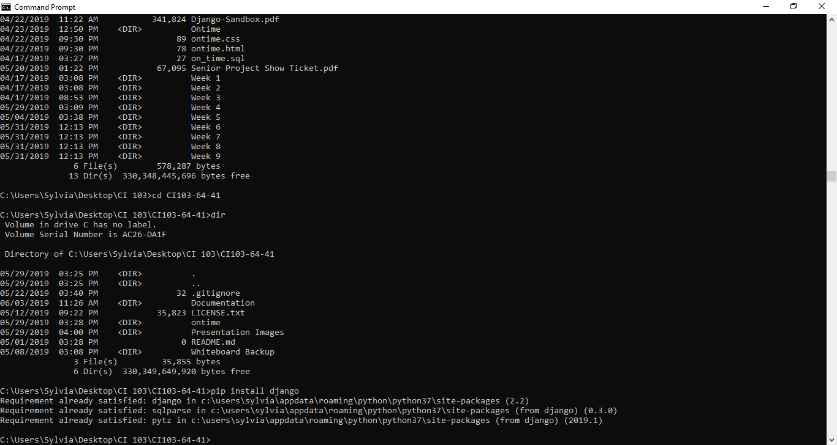

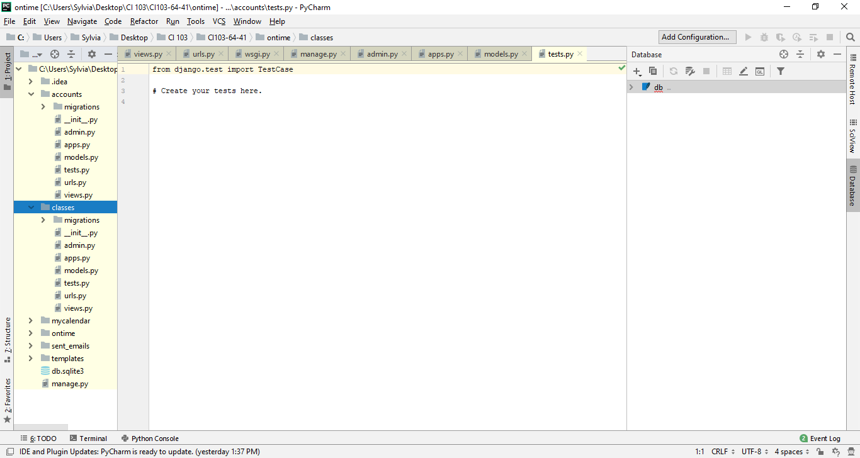

Then open pycharms, thonny, or whatever application you use to write your python code and there you can see there are many classes and libraries integrated with python that you can use in your Django sandbox.

Explanations of error message and troubleshooting guide- An error message can occur when you type the wrong syntax, or your machine does not know how to interpret something. Syntaxes can be very persistent. It is very hard for a machine to understand and interpret what we as humans find easy to learn. Depending on the error, the application should find the line of code where the error occurred and try and find ways to trouble shoot it. There are many online tutorials you can use to find ways to troubleshoot errors.

Here is a very good link to help with installing Django and teaches you everything you need to know- <https://djangocentral.com/how-to-install-django/>

Logging into your tux server:

Tux is the server that runs the Django database below are some images on how to login in to your tux account and entering your server.

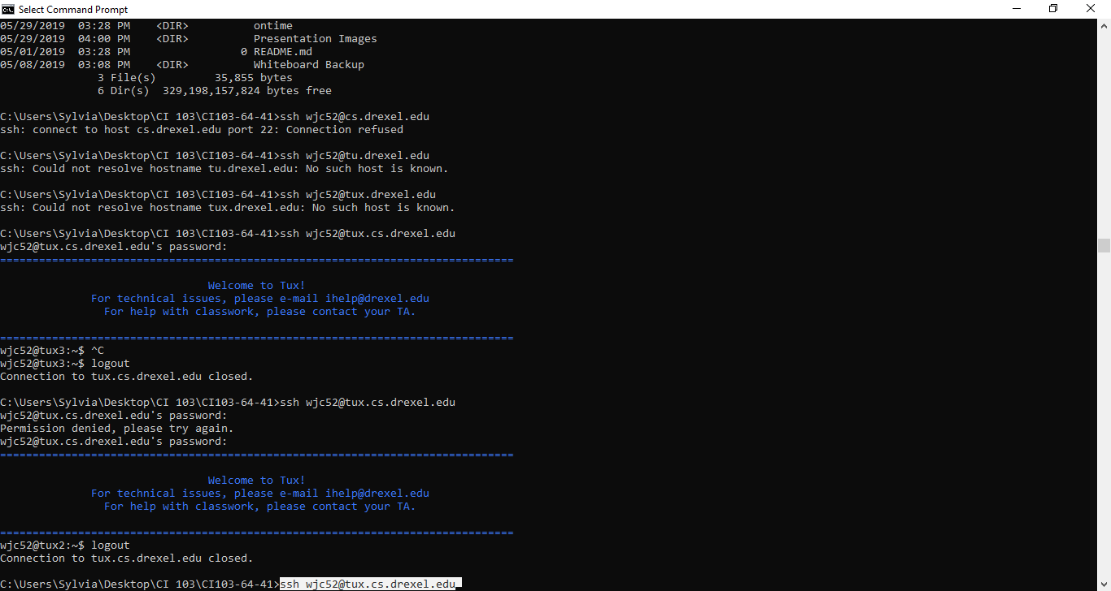

You use the command ssh, then your user id, @tux.cs.drexel.edu. Bringing it all together you would do “ssh [youruserid@cs.tux..drexel.edu](mailto:youruserid@cs.tux..drexel.edu)”

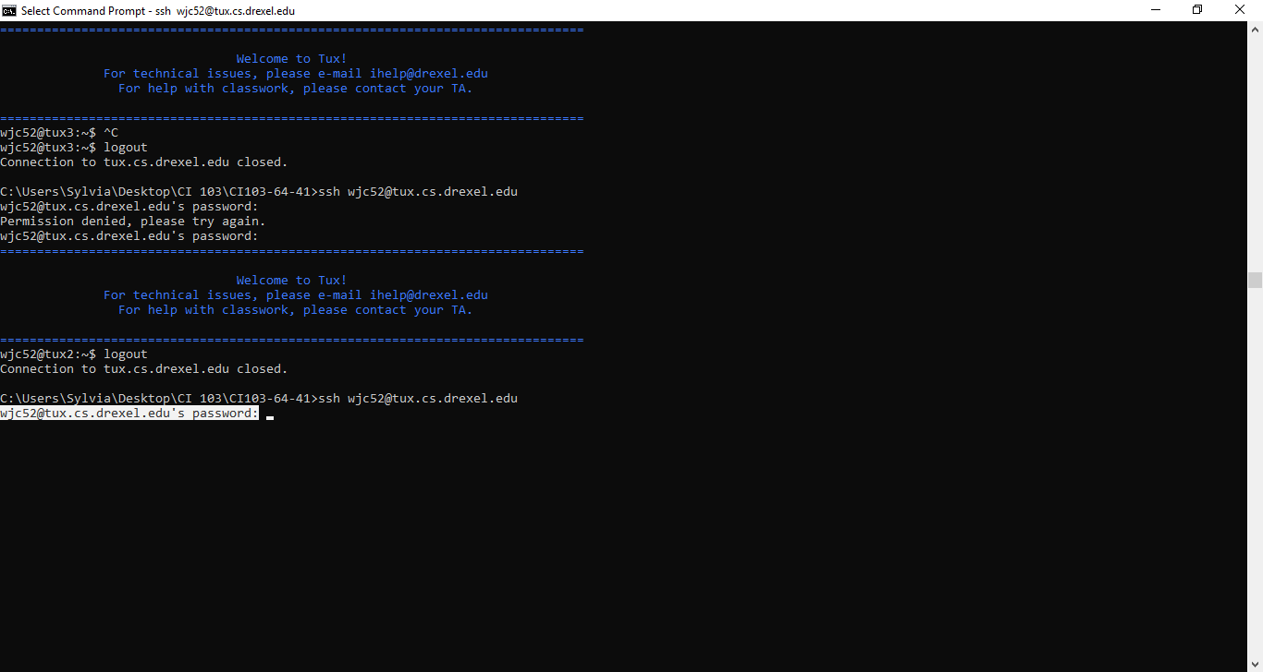

You will then need to enter your password. Your password will not show up on the command line when you type it in. **If you do not know your password contact tux or have any other issues, contact** [**ihelp@drexel.edu**](mailto:ihelp@drexel.edu).

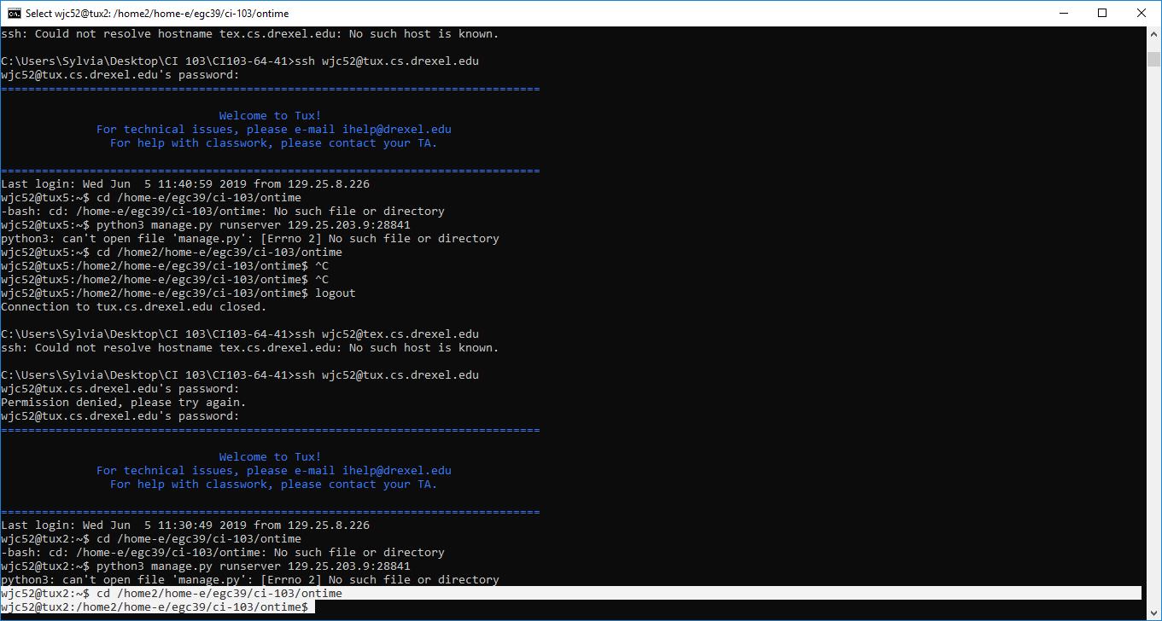

Now we are logged into tux. You will now need to change your directory to “cd /home2/home-whatever letter your user id starts with/your user id/whatever directory you are using/whatever you call your project name” Our example “cd /home2/home-e/egc39/ci-103/ontime”

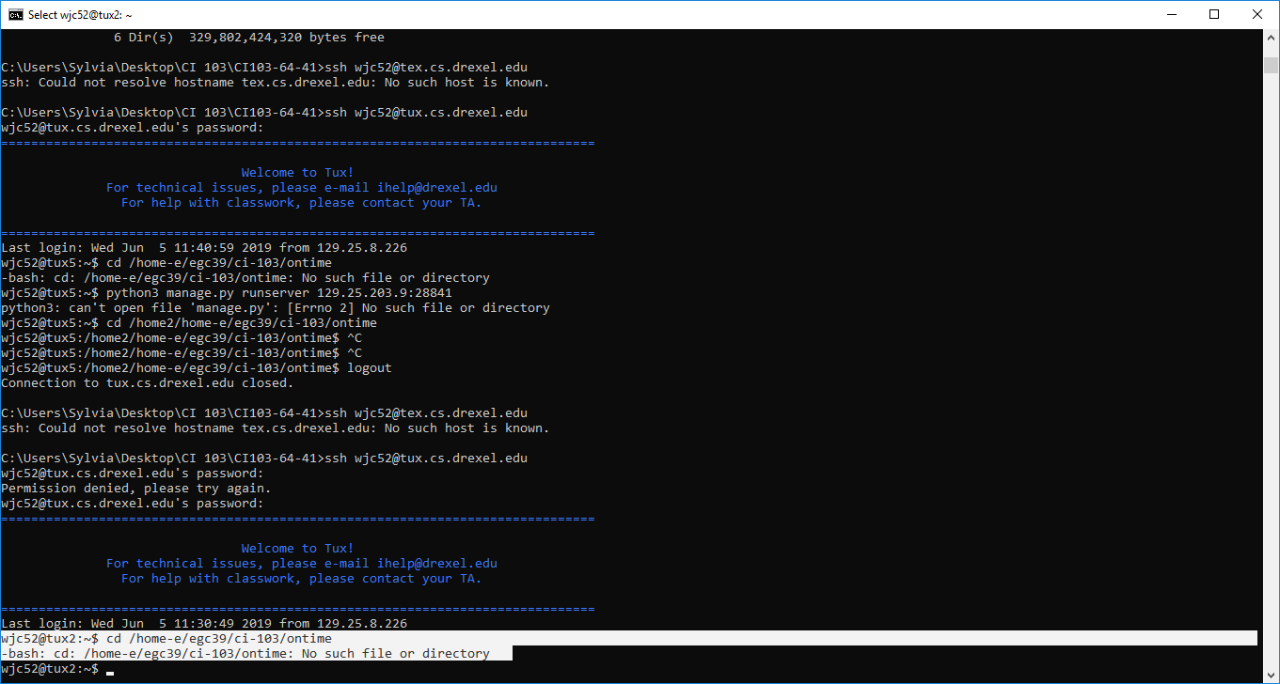

You must use the right syntax otherwise tux will not know what you are trying to execute.

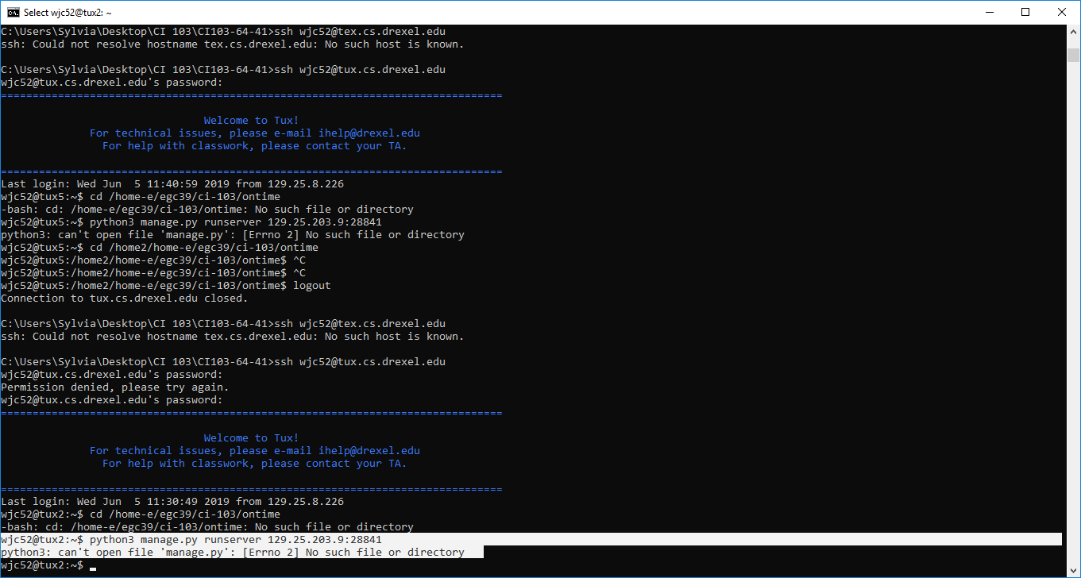

If you try to run the server right away, tux will not understand what you are trying to do. So it is important that you have the right syntaxes for your commands.

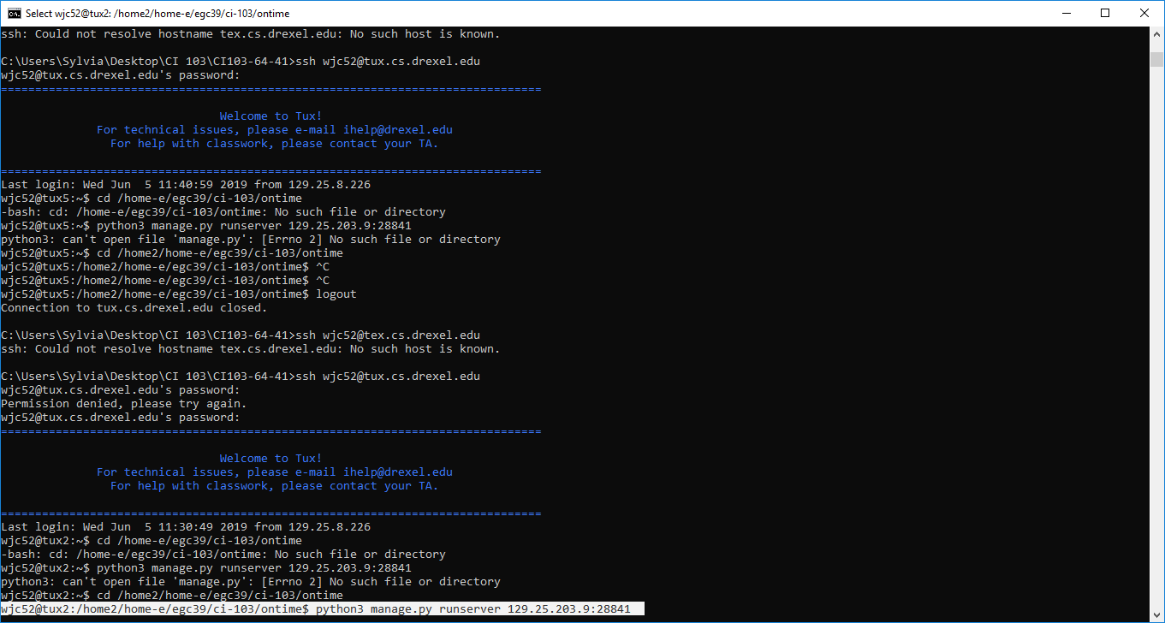

**Once you are in the right directory, you now can run the server using this command “python3 manage.py runserver with whatever your IP address is”** this is our command with our IP address “python3 manage.py runserver 129.25.203.9:28841”

Contacts:

In case there are any issues please contact any of our developers. Below are the emails and phone numbers.

Billy Carroll: (484) 238-5590, [wjc52@drexel.edu](mailto:wjc52@drexel.edu)

Emma Carton: (610) 220-3579, [egc39@drexel.edu](mailto:egc39@drexel.edu)

Lupe Fernandez-Nunez: (302) 510-0830, [gf347@drexel.edu](mailto:gf347@drexel.edu)

Dylan Robak: (610) 999-8780, [dnr44@drexel.edu](mailto:dnr44@drexel.edu)

Aiden Dorris: (484) 319-0275, [asd95@drexel.edu](mailto:asd95@drexel.edu)

About File:

Developers-

Billy Carroll, wjc52, Graduation Year- 2023

Emma Carton, egc39, Graduation Year- 2023

Aiden Doris, asd95, Graduation Year- 2023

Lupe Fernandez-Nunez, gf347, Graduation Year- 2023

Dylan Robak, dnr44, Graduation Year- 2023

What is Ontime about?

Ontime is an online web application that allows students to be able to input their classes into their calendar. When the student is adding a class to the calendar, they can put in other information about their classes besides the class name such as the time, the teacher or professor they have, the number of credits that class is worth, the location of their class, and any possible additional criteria. We want students who are struggling with time management to have an application to aid them with managing their heavy workload more efficiently. With Ontime, our goal is to have students have the ability to work smarter not harder so they can enjoy other activities that are important to them such as sports, clubs, work, leisure time, or any other things that are important to students.